Program to find minimum and maximum value of a node from a doubly linked list

//find min and max element in a doubly linked list

public class minmaxdoubly{

class Node{

int data;

Node previous;

Node next;

public Node(int data) {

this.data = data;

}

}

Node head, tail = null;

public void addNode(int data) {

Node newNode = new Node(data);

if(head == null) {

head = tail = newNode;

head.previous = null;

tail.next = null;

}

else {

tail.next = newNode;

newNode.previous = tail;

tail = newNode;

tail.next = null;

}

}

public int minimumNode() {

Node current = head;

int min;

if(head == null) {

System.out.println("List is empty");

return 0;

}

else {

min = head.data;

while(current != null) {

if(min > current.data)

min = current.data;

current = current.next;

}

}

return min;

}

public int maximumNode() {

Node current = head;

int max;

if(head == null) {

System.out.println("List is empty");

return 0;

}

else {

max = head.data;

while(current != null) {

if(current.data > max)

max = current.data;

current = current.next;

}

}

return max;

}

public static void main(String[] args) {

minmaxdoubly dList = new minmaxdoubly();

dList.addNode(5);

dList.addNode(7);

dList.addNode(9);

dList.addNode(1);

dList.addNode(2);

System.out.println("Minimum value node in the list: "+ dList.minimumNode());

System.out.println("Maximum value node in the list: "+ dList.maximumNode());

}

}

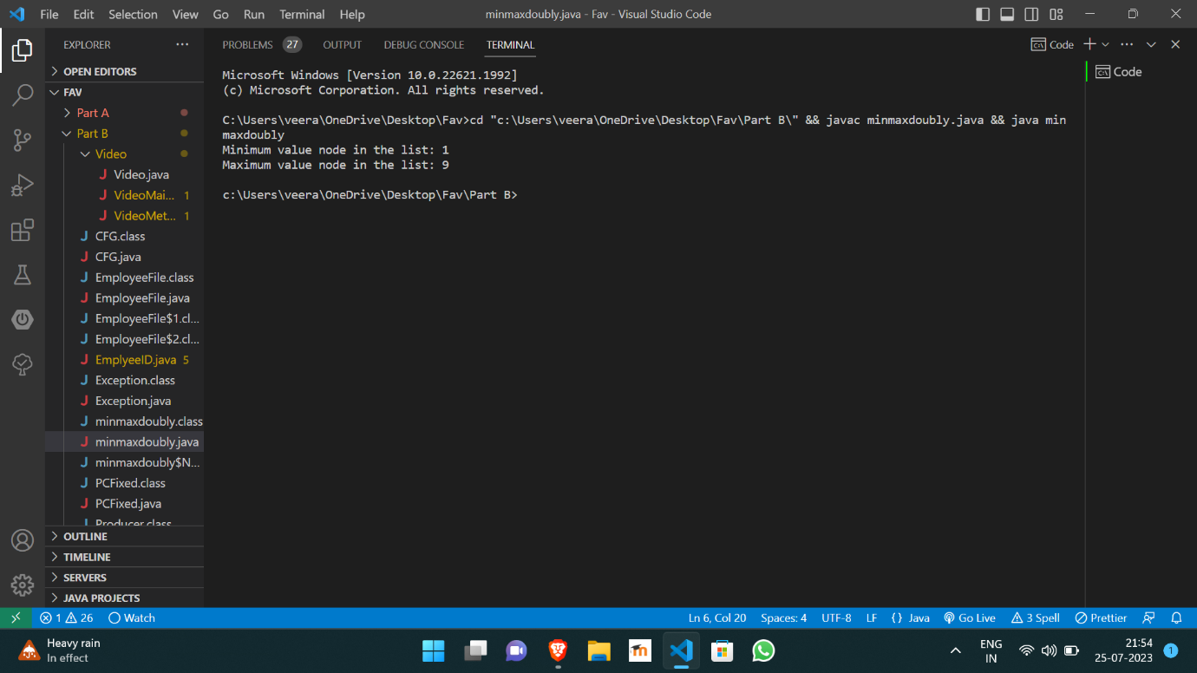

https://github.com/Veeragoutham04/Java_Lab/blob/main/minmaxdoubly